# Andromeda Cartographers

Present:

Universal Lens

## Executive Overview

**Problem**: Nasa researchers will have tons of FITS image data to analyse and categorize while AI can help with categorization by finding patterns and such the human input is always needed. This is time consuming but necessary in order to properly categorize celestial objects and make sure that any uncaught elements are addressed properly.

These images are too large for the average computer to read properly thus researchers can only rely on the personnel that has access to the machinery used by NASA.

**Solution**: Our solution is to create an application that can take large images and break them down into smaller readable images which are then put together in a 3D model like mold, inspired by google maps, that allows them to zoom in and out of the image as well as scroll through it. This is aimed at the general public that can use our application as a relaxing “find the object” game where they will be given pieces of a large image and asked to find and categorize objects after a short tutorial.

The categorization done by users will be stored in a large dataset that allows researchers to compare AI categorization to Human categorization and document it.

Similar projects have been made in the past such as BorderLine Science

**Future implementation:**

This solution is aimed at Nasa’s study of large scale telescope images as of now as it helps navigate said image as well as study celestial objects at different resolution levels. However, it is not limited to the field. Such an application can be used for any field such as the medical field by exploring microscope images or high resolution medical scans,  or even the art and cultures field by allowing comparison at different zoom levels of artworks or study patterns of artifacts from ancient civilization (archeology).

This is to say that we will mostly concentrate on telescope images the solution proposed is ideal for a myriad of fields in different uses.

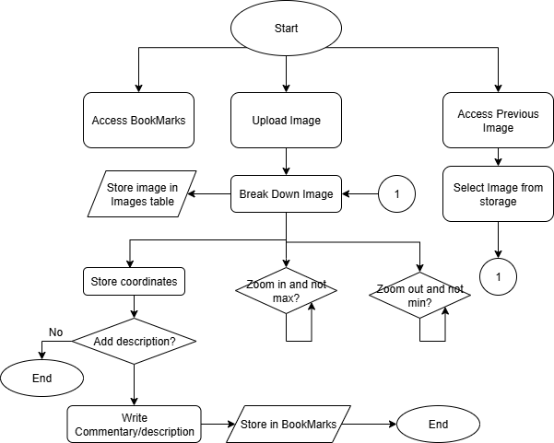

## Key Advantages:

* Zoom in/out
* Save coordinates with notes and categorization
* Load progress -> finding patterns found by the ai
* Login
* Free to use for both researchers and users.
* The solution is expandable to multiple fields and has the opportunity to grow.

## Challenges:

What is the best way to zoom into an image without losing quality and keep the same high resolution?

How can one locate themselves in the image, how to use coordinates on space? -> Using geo-referencing points. -> FITS images provide celestial coordinates

## Additional Notes:

FITS reader is better for analytics and advanced research however it takes more storage and power so for a simple solution as of the one for today we will be using jsFITS I/O as it is more compatible with the web and Nodejs the use of FITS reader has been discussed for future implementations

## Resources:

* NirCam
* OpenSeaDragon (like Leaflet, but better)
* Nasa Images ()
  + FITS format
* AI
  + Deepseek
  + Perplexity
* Node JS
* jsFITS I/O library
* GitHub
* Leaflet
* MongoDb
* James web telescope
* How to handle datasets-> open data and information portal government of Canada: <https://search.open.canada.ca/data/>
* Tutorials on GitHub
* Micro application -> easier visualization of data
* Canadian Astronomy Data Centre archive -> collections (has telescope data)
* Canadian Astronomy Center
* EODMS
* Registry of open data of AWS
* CSA open data
* European Space Agency

Notes from astrophysics coach:

--------------------------------------------------------------------------------------------

*Right ascension and declination are assigned to every point/coordinate*

*To map objects on coordinates systems.*

*Celestial sphere -> so we need trigonometric functions*

*Paralex/parallax method to measure objects nearby*

*With just the angles, you can reference objects in the sky and map*

*------------------------------------------------------------------------------------------*